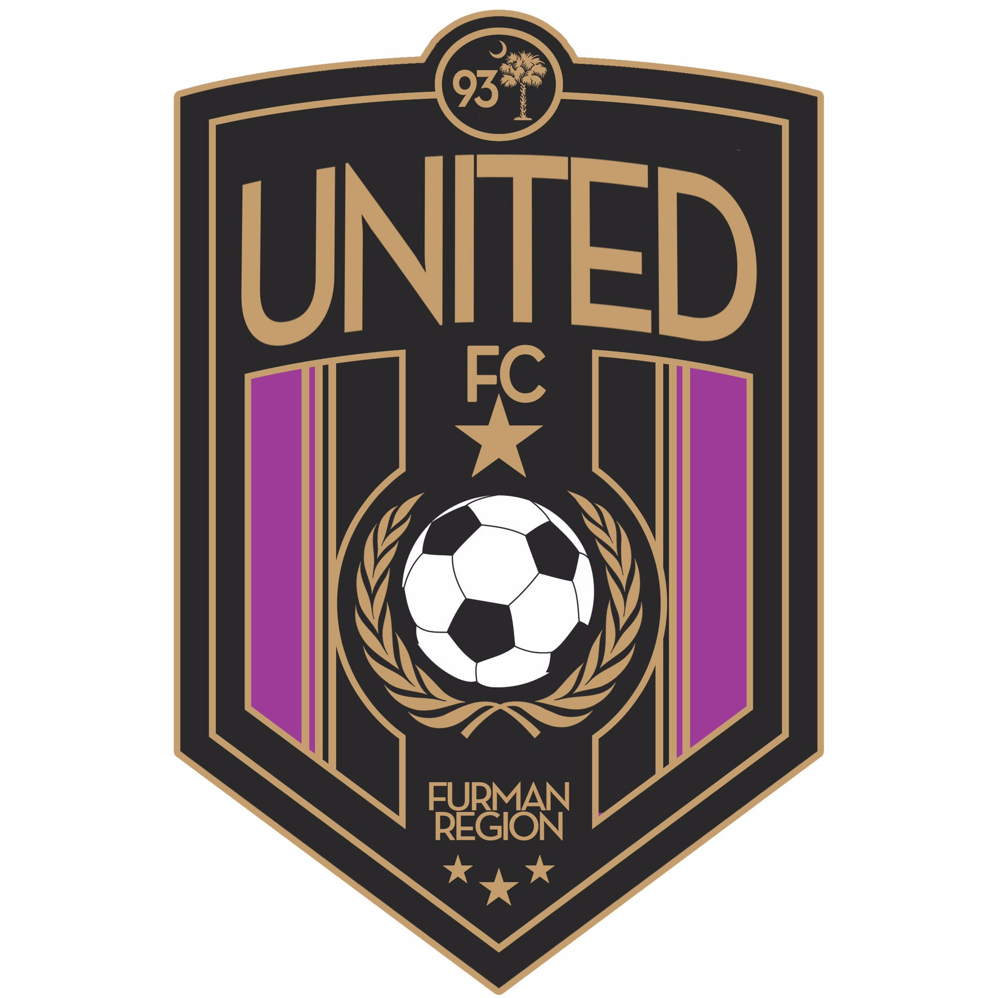
ACADEMY PROGRAM - PLAYER CONTRACT
Fall 2021-Spring 2022
(Parent signature required)

Thank You for participating in the United FC Furman Academy Program Evaluations for the 2021-2022 season! If you are selected, it is vital that you fully understand the commitments and expectations. The Academy Program is a competitive soccer program focused on athletes who love the sport of soccer and are serious about player development. This level of soccer will ultimately prepare players to compete in the future at the highest levels of club, high school, and college soccer.

The United FC Furman Academy is a 9-month program commitment. Players are financially obligated to the full program fee and tournament team fees for the Fall 2021-Spring 2022 seasons.

Player Expectations
- Commitment – Player commitment is an important part of competitive team sports. For the development of the player, participation needs to be the top priority during the Fall league seasons. Please be aware that overlapping the club seasons with other sports makes the player more susceptible to injury. The club recognizes the need to balance other sports, school, extra curricular activities, and family schedules.
- Attendance – The player is expected to attend all training sessions, tournaments, and league play. Please be on time.
- Communication – Communicate with your coach regarding school, attendance, injuries, or other things that will affect your ability to uphold your time commitments with your team. No player will be dropped from a team during a seasonal year unless it is for disciplinary reasons or failure to fulfill financial obligations.
- Equipment/Gear – It is the player’s responsibility to come prepared with their training jersey, cleats (no metal), shin guards, size 5 ball, water, and for goalies – goalkeeper gloves. Purchase a Select uniform kit at First Team Sports (in July – cost $125+tax). Players must get a unique number from their coach.
- Annual Evaluations – Players are required to be evaluated each year as an important part of player development.
- Playing Time – Playing time is at the Coach’s discretion. Players need to understand that many factors go into the amount of playing time or where they play on the field. Concerns and questions should be directed to your coach.

Parent Expectations:
- Communication – Our Coaching Staff will make themselves available at appropriate times for discussions with parents or players. Players should be encouraged to speak up and communicate for themselves whenever possible. Coaches will instruct your child to ignore and deal with adverse conditions such as bad referees, name-calling, foul language, rough play, cheating, poor weather, negative behavior by parents, opponents, coaches, or other difficult circumstances.
- Encourage – Vocal support and positive encouragement are welcome after a good play. Please do not criticize when mistakes are made. The kids are well aware of their mistakes and we teach our players that overcoming and learning from mistakes is an important part of the game and character building process.
- No Sideline Coaching – There will be NO coaching by parents. Comments like “pass”, “shoot”, “run”, “send it”, are all interpreted as instructions.
- Respect – All United FC Furman members are expected to respect the referees at all times – If you have a concern, speak with your coach after the game. No parent should confront or speak negatively at any point, anywhere, to any referee or field official.

United FC Furman
#MoreThanAGame...Building Character and Skill

Academy Program Fee Schedule (Fall 2021-Spring 2022 Financial Agreement)

- Players are obligated to the full program fees including registration deposit, program fee payments and tournament team fees for the Fall 2021-Spring 2022. All financial and time commitments need to be current in order to remain eligible to participate with your team.
- No refunds or adjustments will be issued if a player is unable to train, attend a tournament, or chooses not to complete the seasonal year. Any request for a player transfer will not be approved until Fall 2021-Spring 2022 program fees have been paid.
- Players who withdraw at the end of the Fall 2021 Season to participate in another sport are financially responsible through their Program Payment on November 1st as listed below. This will be their final payment.
- Payments are due by the due dates listed below. Contact the registrar if you have a financial concern.
- Checks returned for insufficient funds will be charged a $30 fee.
- By signing this, you are committing to all financial obligations, player and parent expectations as listed in this contract.
- Tournament Team Fees are required by all players no matter what your playing status is at the time of the event.
- Program Fees #1-#9 can be paid in a lump sum amount or 9 equal payments as shown below.

Due Date | Program Fees | Amount | Notes
May | Registration Deposit | $250 | You must register within 3 days of roster announcements for your player
June | Fall Tournaments Team Fee | ~$150 | Teams will attend 2-3 per season – fees will be confirmed for team before due date
July 1 | Program Payment #1 | $83.33
August 1 | Uniform Kit | ~$125+tax | Purchase at First Team Sports – See Coach for Jersey Number Assignment
August 1 | Program Payment #2 | $83.33
September 1 | Program Payment #3 | $83.33
October 1 | Program Payment #4 | $83.33
November 1 | Program Payment #5 | $83.33
December 1 | Program Payment #6 | $83.33
December 15 | Spring Tournaments Team Fee | ~$150 | Teams will attend 2-3 per season – fees will be confirmed for team before due date
January 1 | Program Payment #7 | $83.33
February 1 | Program Payment #8 | $83.33
March 1 | Program Payment #9 | $83.33

I have read, understand, and agree to the Player Contract and Financial Agreement of United FC Furman.

Academy Player Name________________________________________ Birth year (circle one) 2010 2011 2012 2013 2014

___________________________________________________________________________________________Date ___/___/___
Parent/Legal Guardian Signature Printed Name

